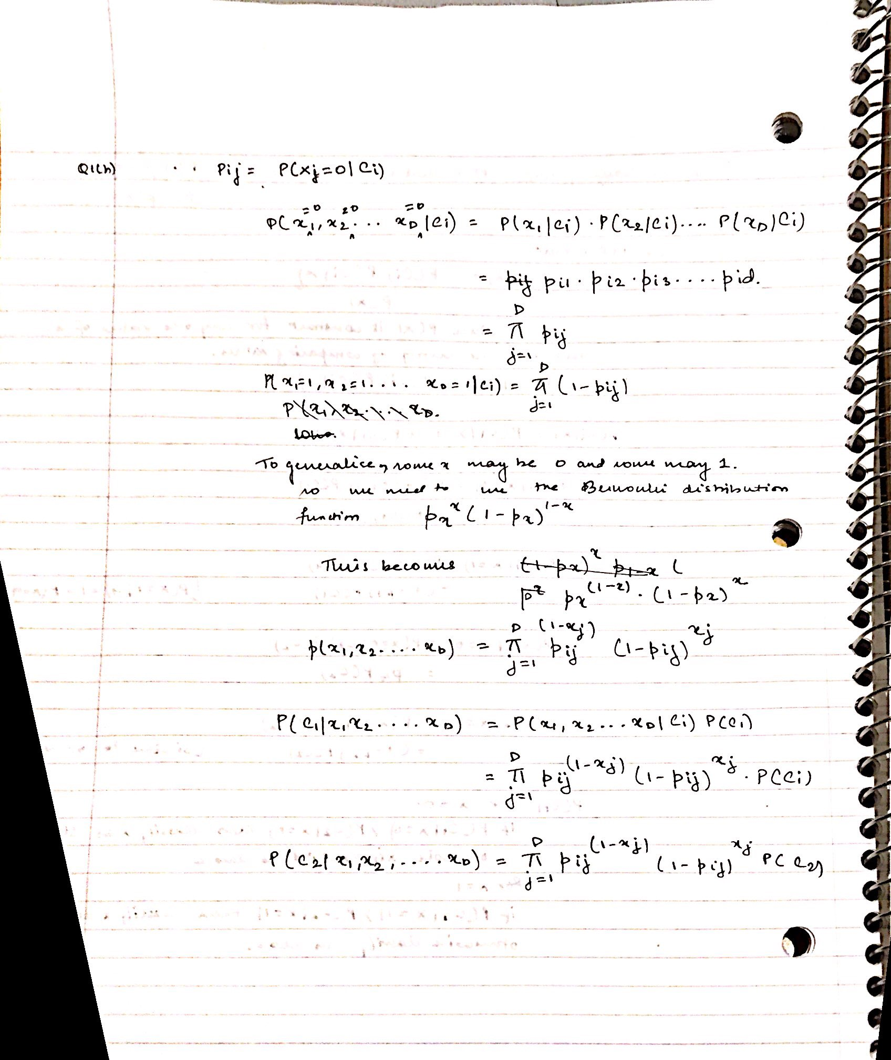

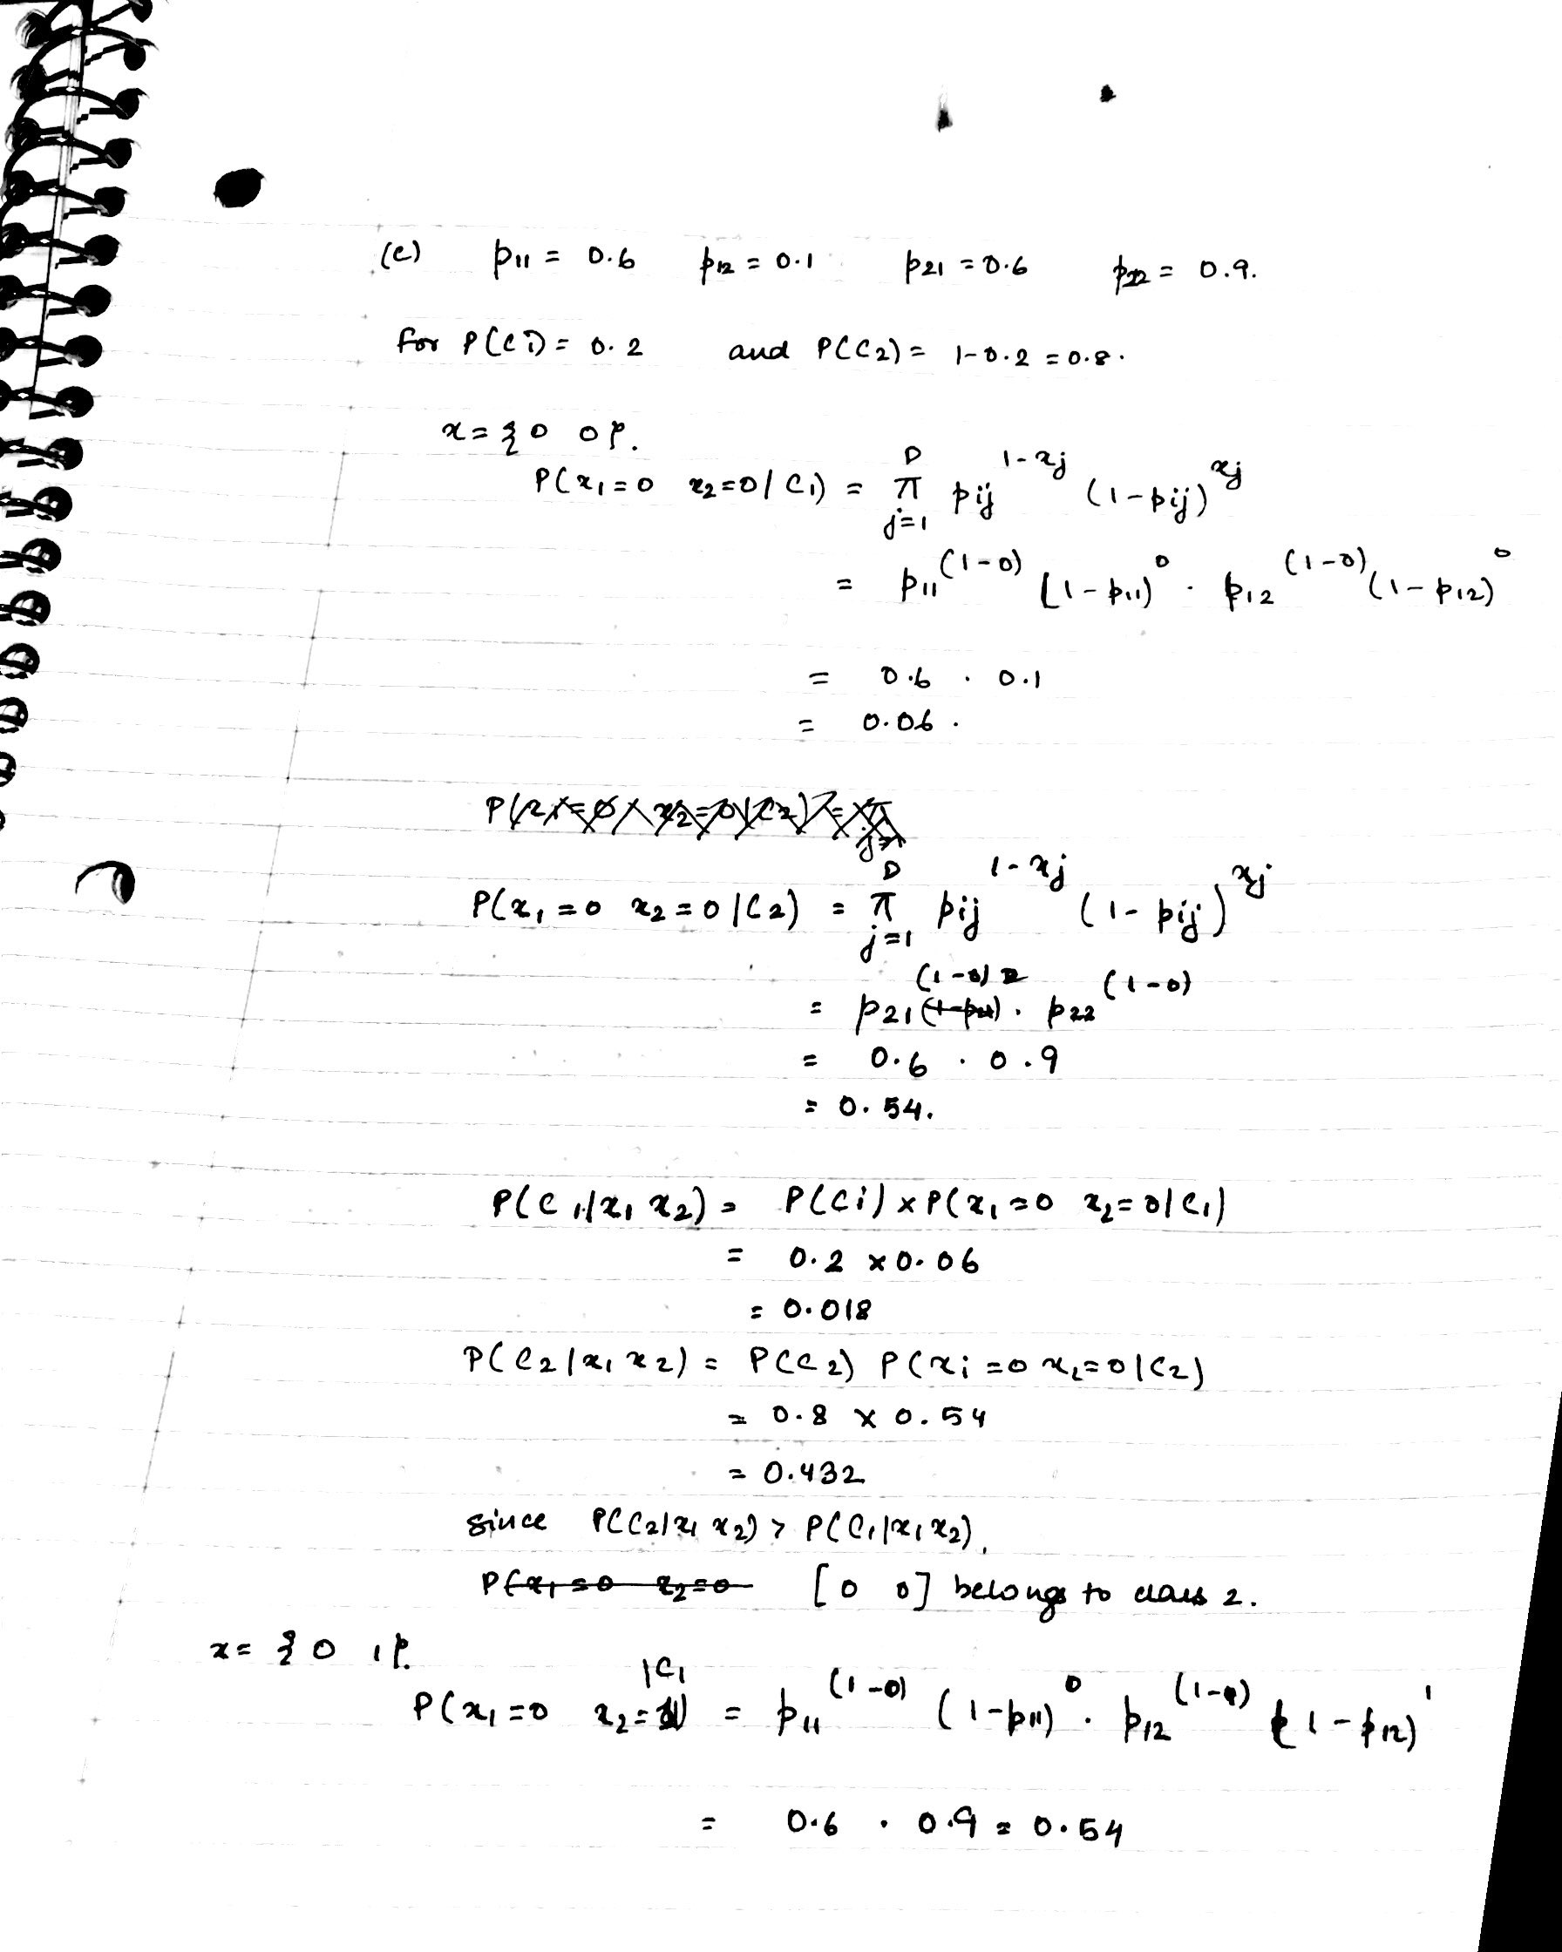

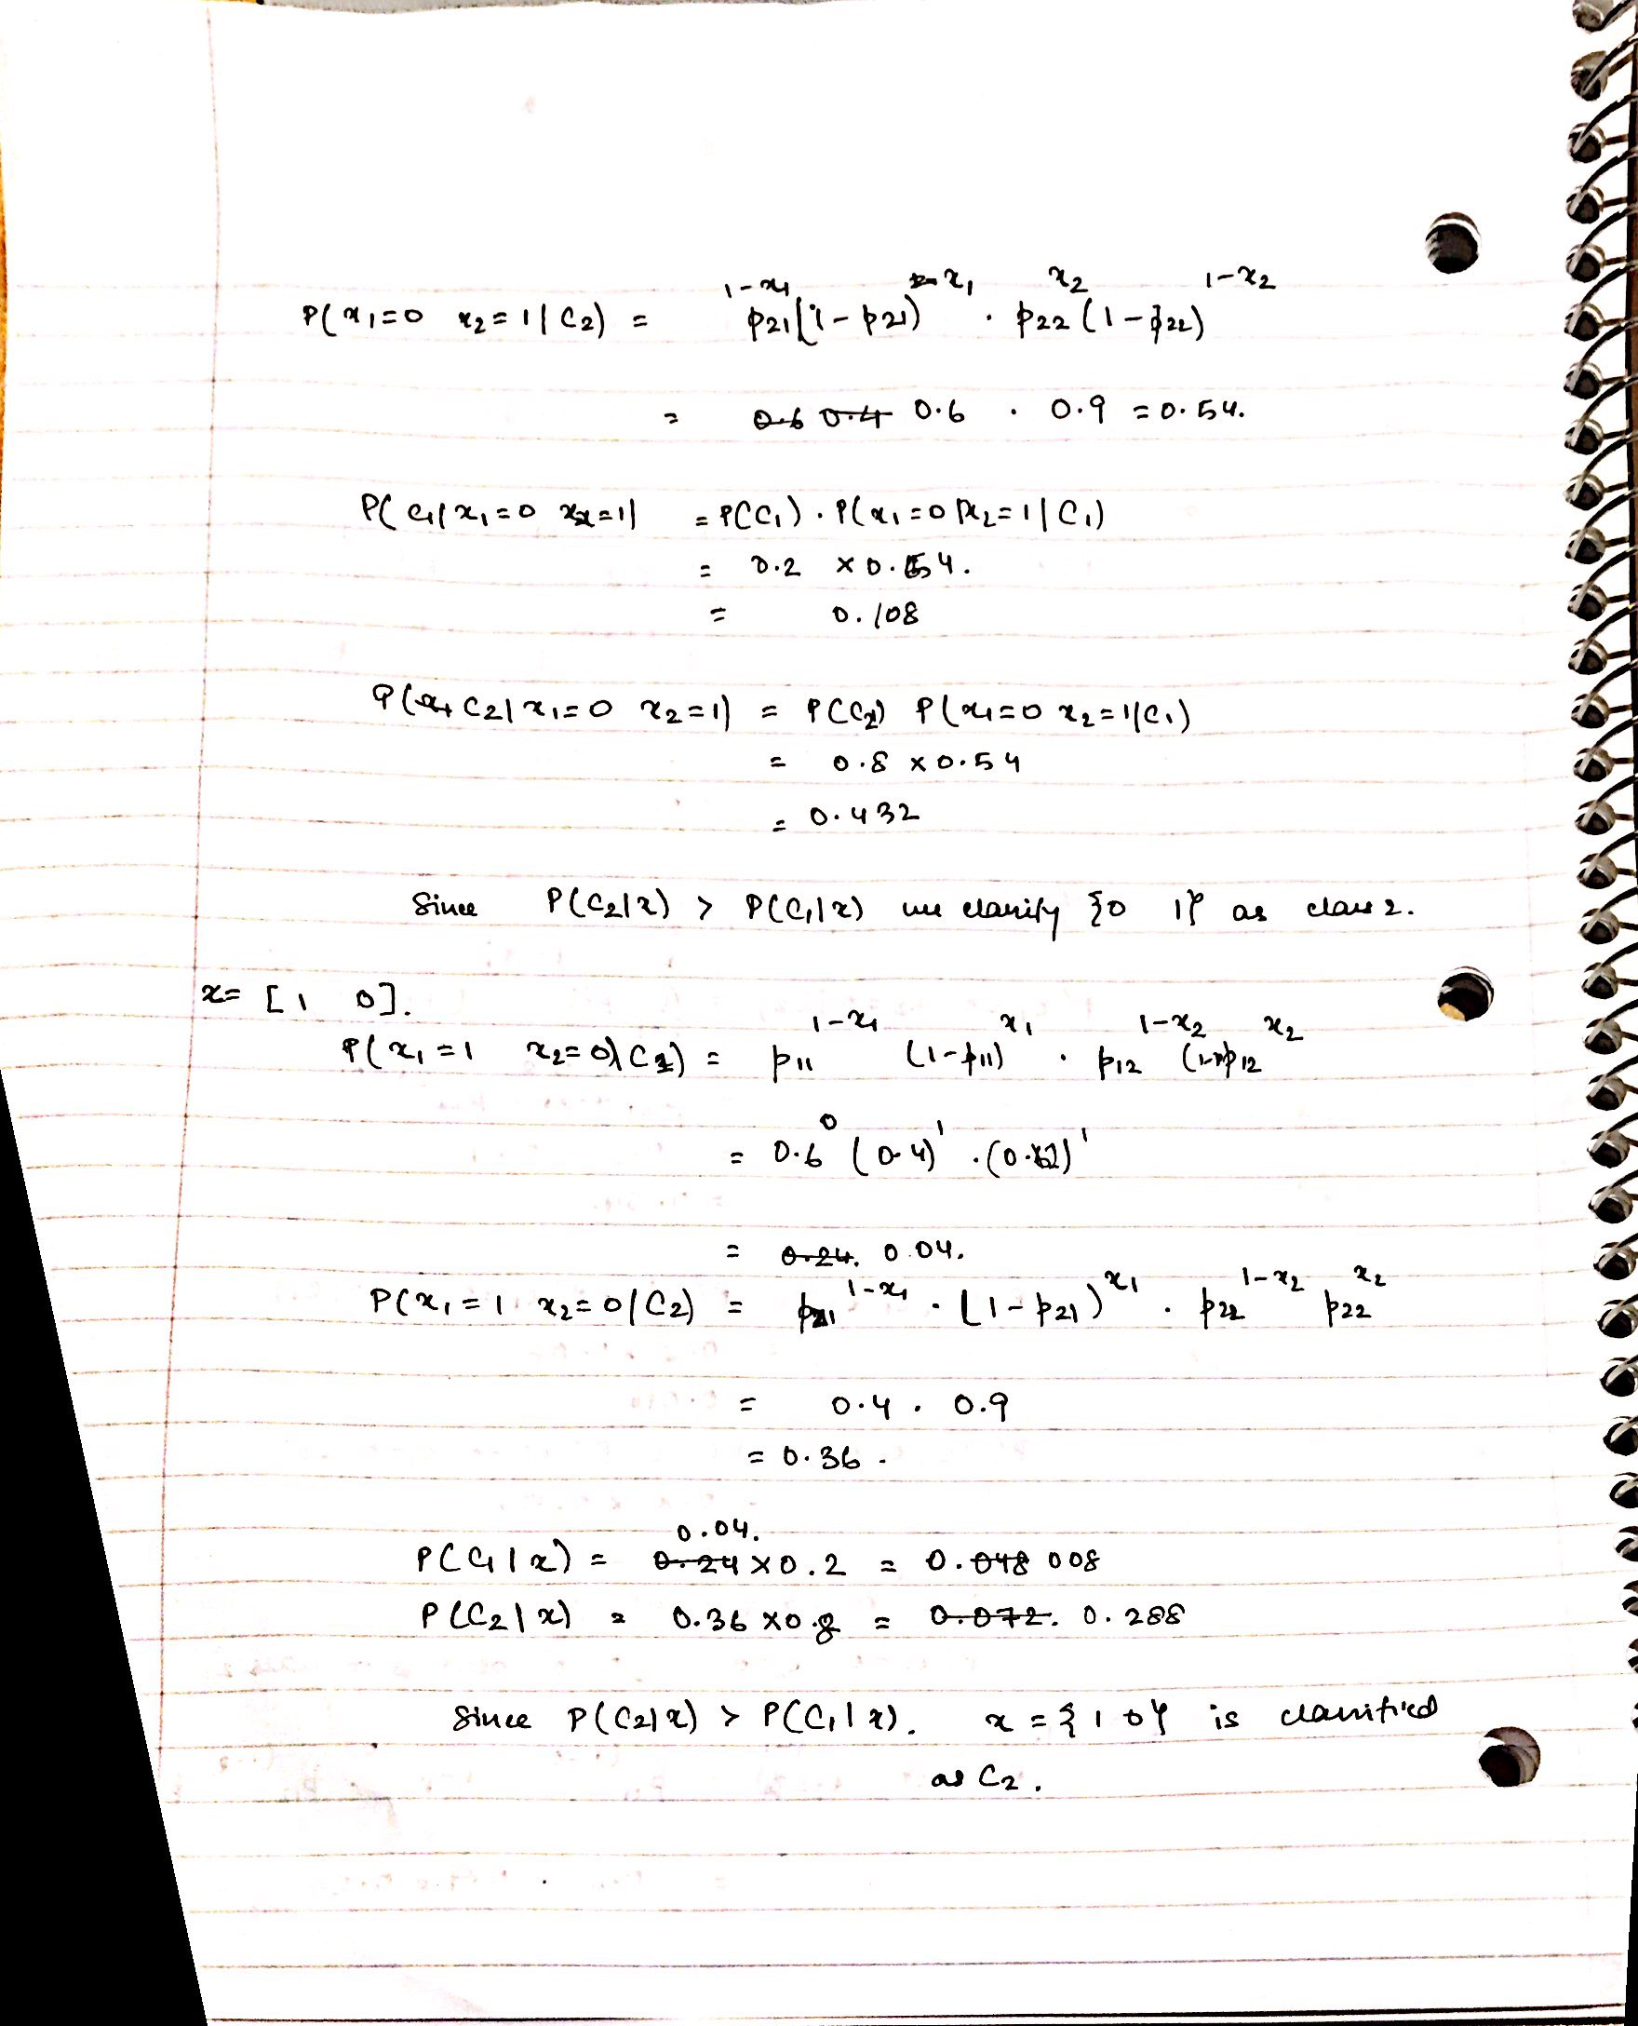

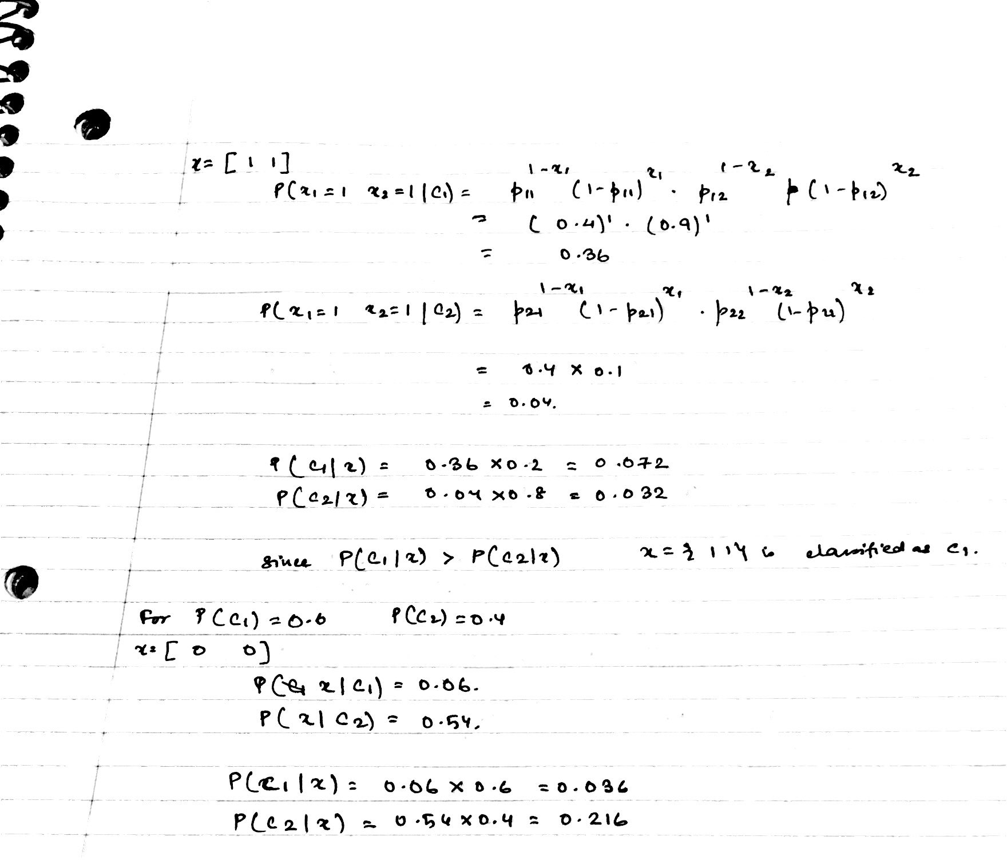

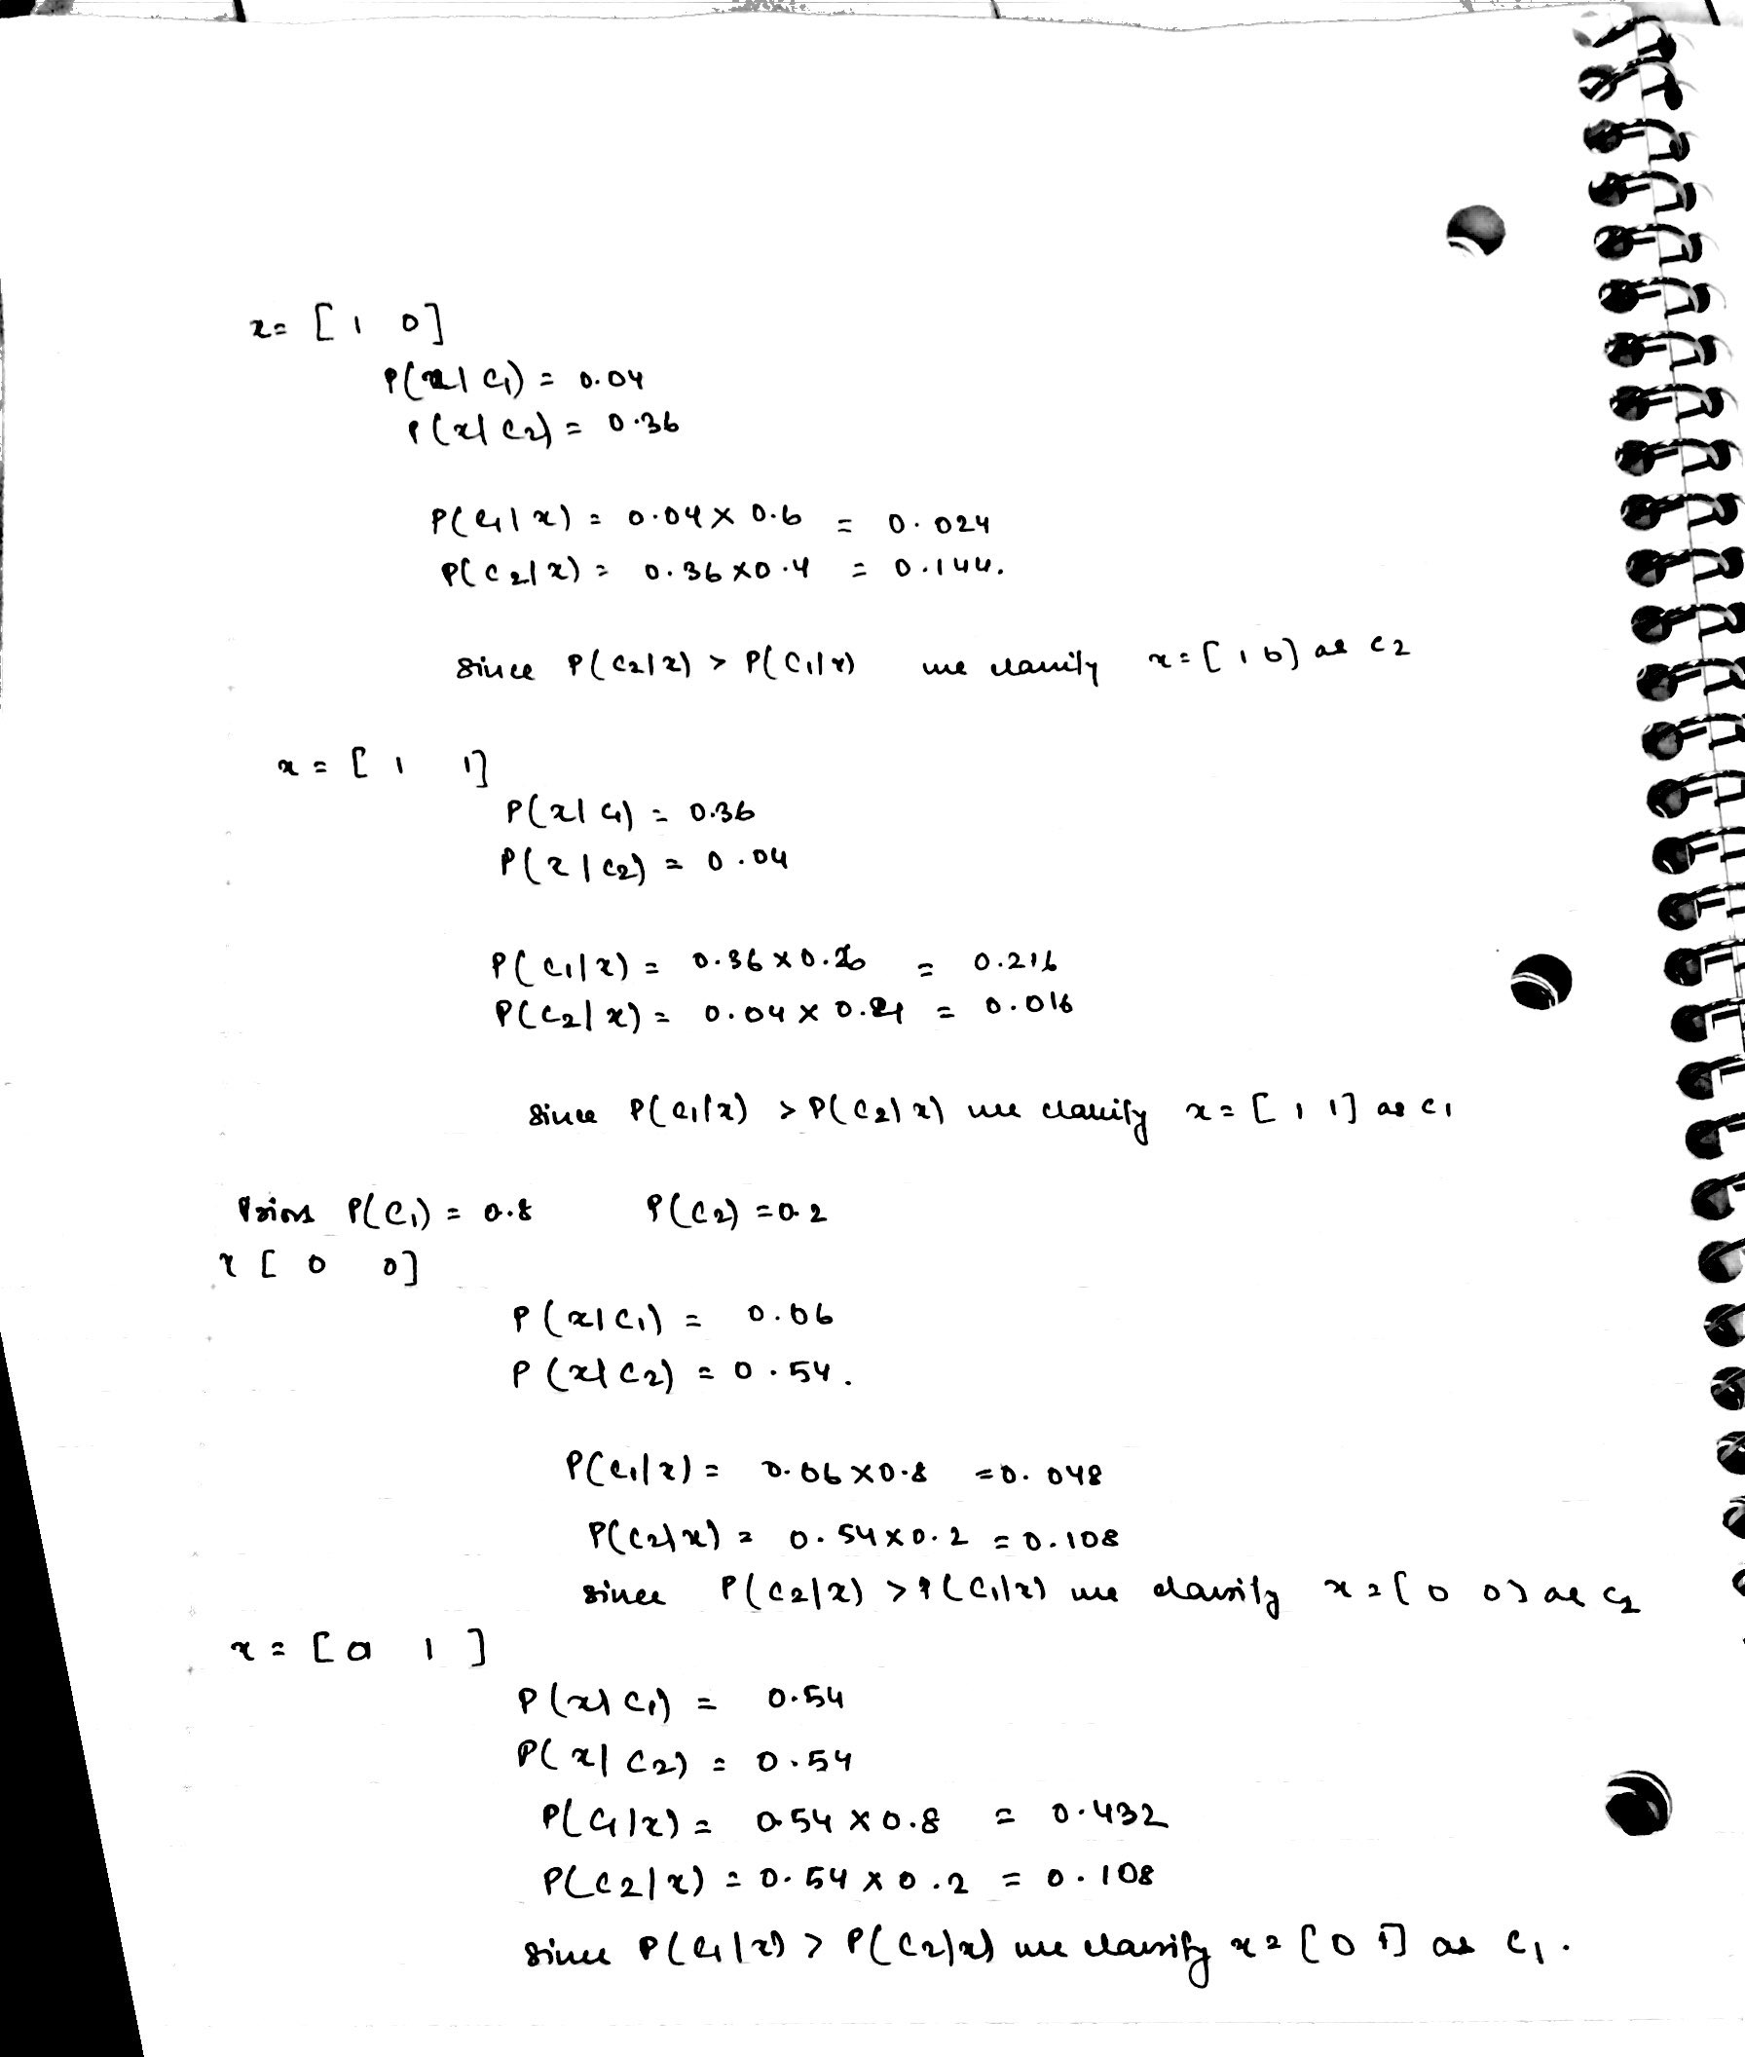

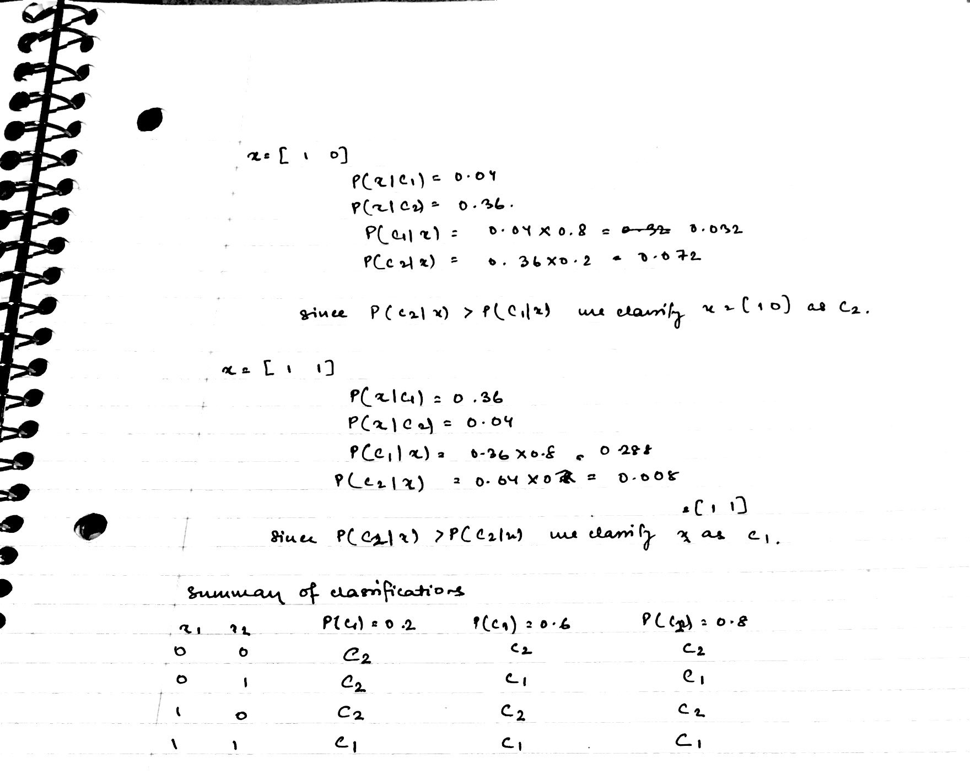

Q2a
. 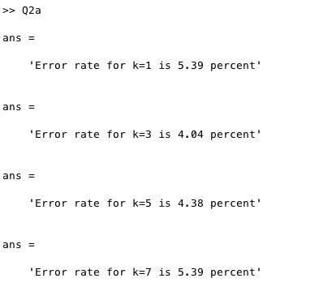

Q2b
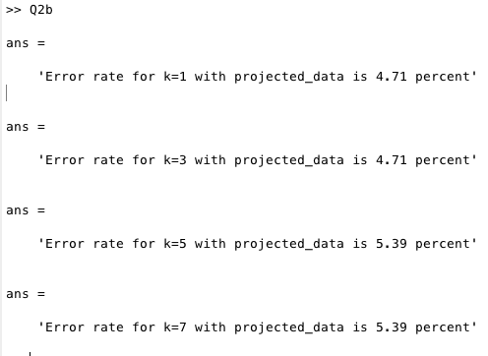

The plot of variance is given below, the principal number of components that explain 90% of varance is 21.
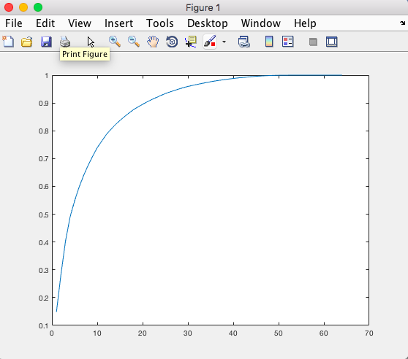

Q2c. The plot of the data on the first 2 prinicipal components is given below.
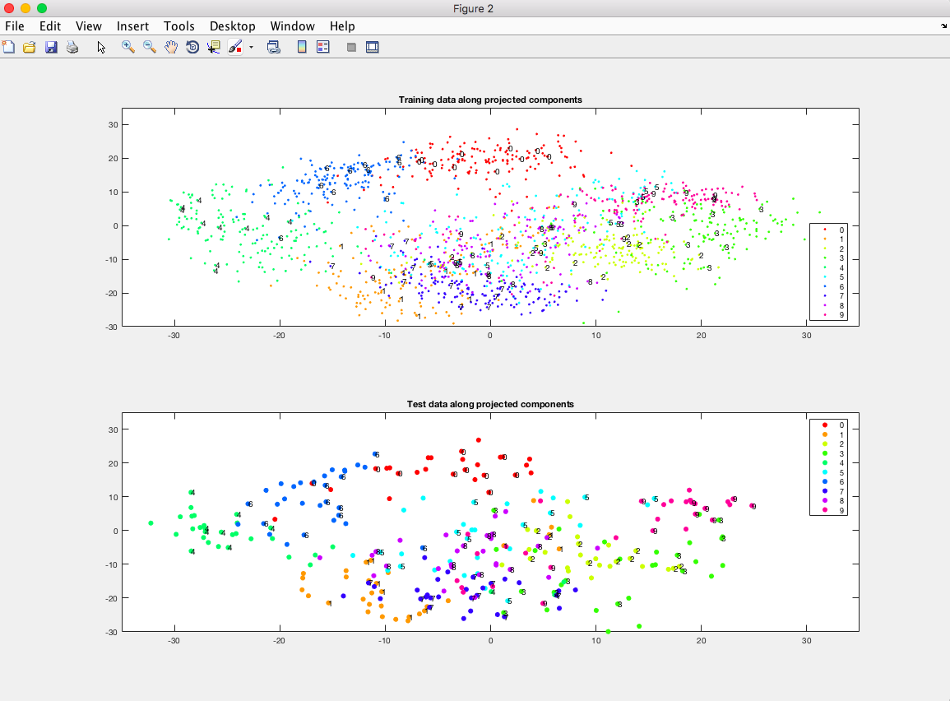

The plotted data of both test and train data is given.

2d
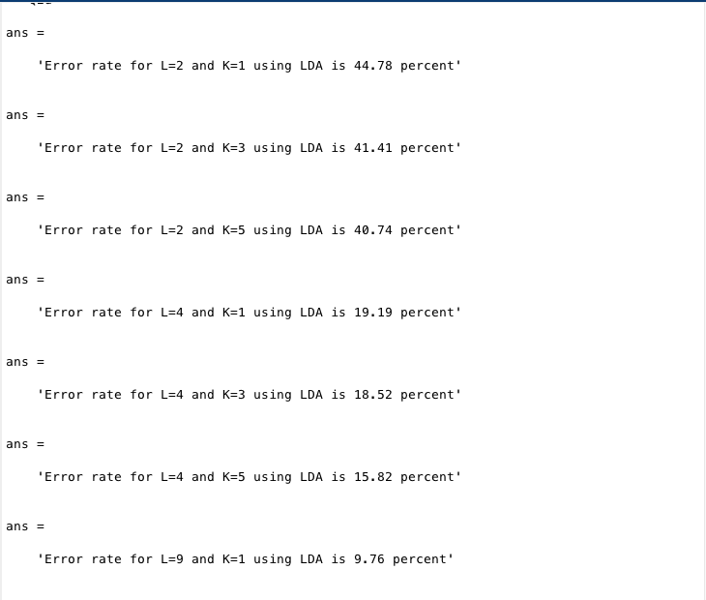
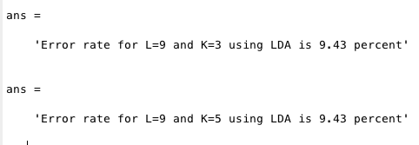
Q2e
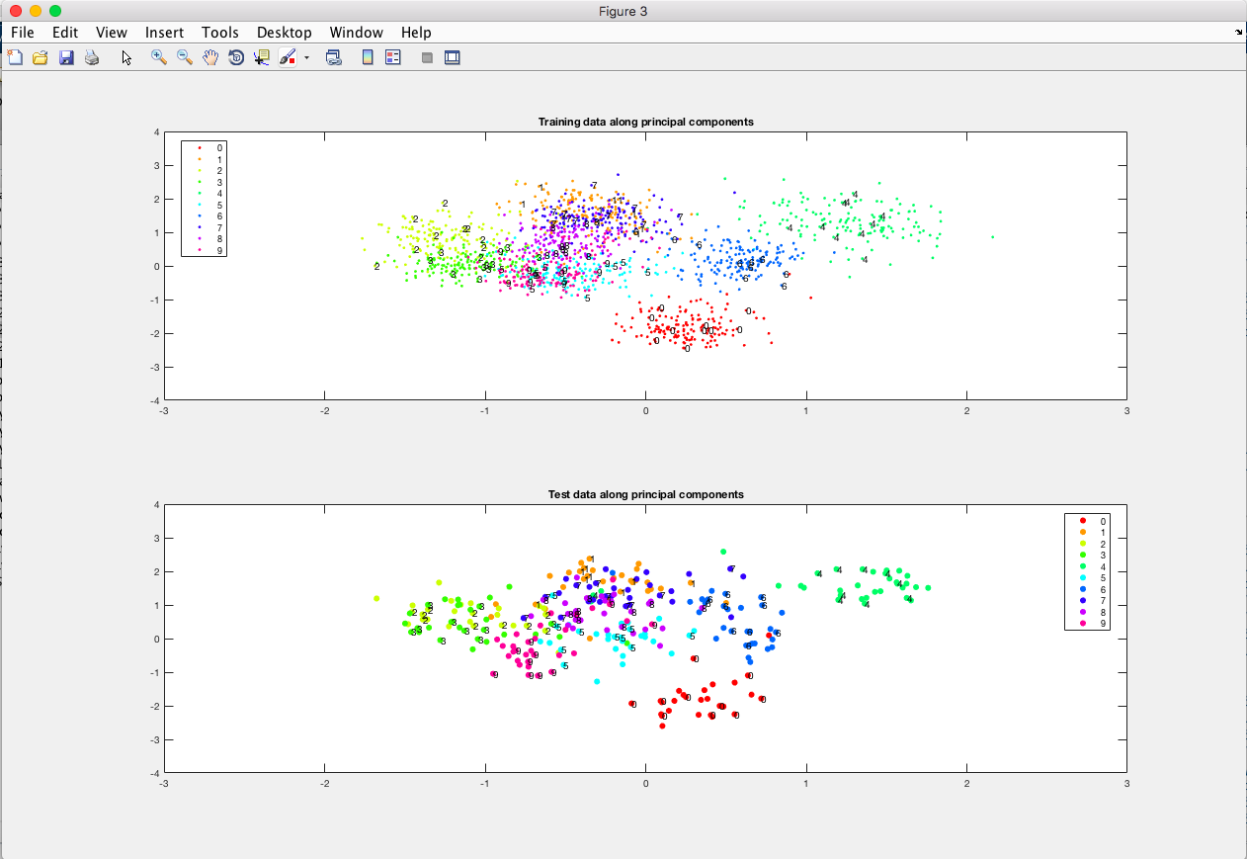

Q3a
The first 5 eigenfaces are: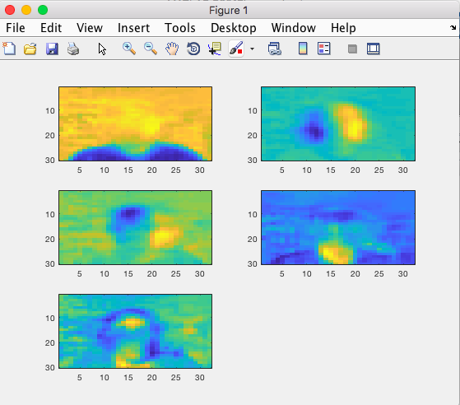

Q3b. The k-values that explains 90% of variance and the error rates of using these principal components with knn is given below. The knn error peaks at k=1.

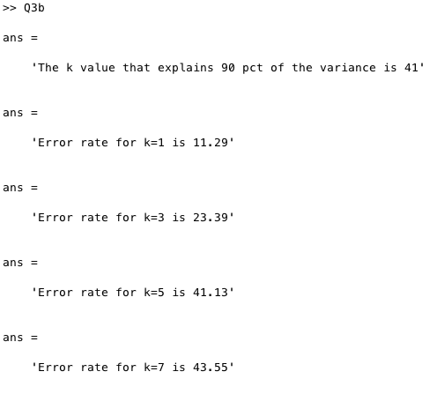

Q3c. The first five faces from reconstruction are as follows. As we can see, when k=10, the images are highly pizelated, and pictures get clearer as we increase k to 50 and 100. This can be explained by the fact that when we use lesser k values and reconstruct, we use the mean of the observed features to estimate and the lesser features lead to poorer estimates. 